Mrs. Menicucci

Physical Science 2024

Week 10

October 21 – October 25

Mon 10/21

* Vid: Chicken Wedding Song (1:00) <https://www.youtube.com/watch?v=Xbo_1k4aSjA>
* Lab: What is a Wave? Students answer the first four questions about the video, then move on to the Straw Kazoo (materials required are a straw & scissors)
* Guide students through the observations on the lab sheet
* Class reading with side notes: What is sound?

Tu 10/22

* Lab: Frequency & Pitch class activity (this activity includes the wave speed equation)
* Catch up

Wed/Thurs

* Prac: Wave speed calculations

Fri 10/25

* NEVADA DAY HOLIDAY!

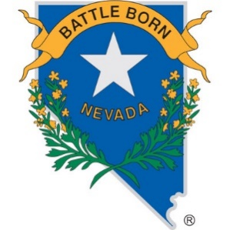

To contact Mrs. Menicucci use email:

[dmenicucci@washoeschools.net](mailto:dmenicucci@washoeschools.net)

WEBSITE: <https://www.washoeschools.net/dmenicucci>